Using Microsoft visual C++ version 6.0

1. Create a folder and a subfolder within it. Here, I called the main folder “project”, and the subfolder “files”, to remind you that that is where you should put all the files. Using a web browser, connect to http://rabbit.eng.miami.edu, go to “class related material”, then “The programming library: downloads and documentation”, and download the two files called “library.h” and “library.obj”. Save them in the inner subfolder.

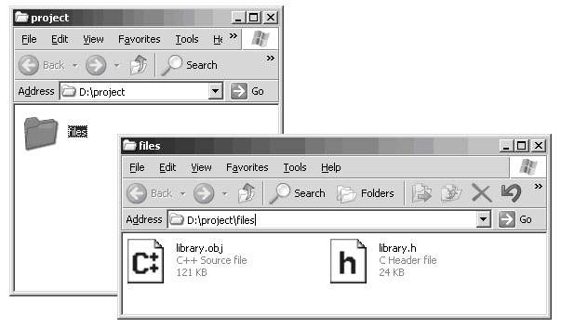

2. Find Microsoft Visual C++, and start it.

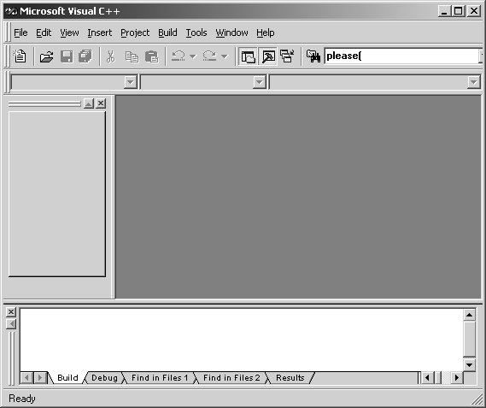
3. From the FILE menu, select NEW. In the new window select “Win32 Application”, then set the Location to be the first folder that you created (NOT the subfolder), then set the project name to be the name of the subfolder. As you type the subfolder’s name, you’ll see that the Location also changes. After those three inputs, the dialogue window should look just like this. Press OK. (This is where we realise that “files” wasn’t a very good name for the subfolder; it had become the name of the program we are creating. Oh well, we’ll know better next time).

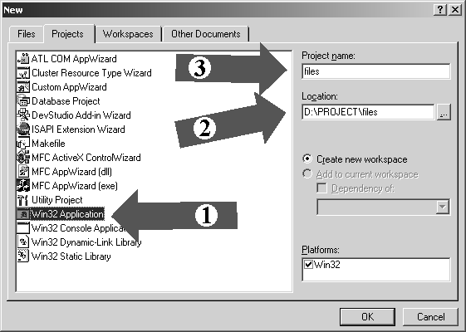

4. In the next little window, make sure you select AN EMPTY PROJECT, or it will fill your program with meaningless gibberish.

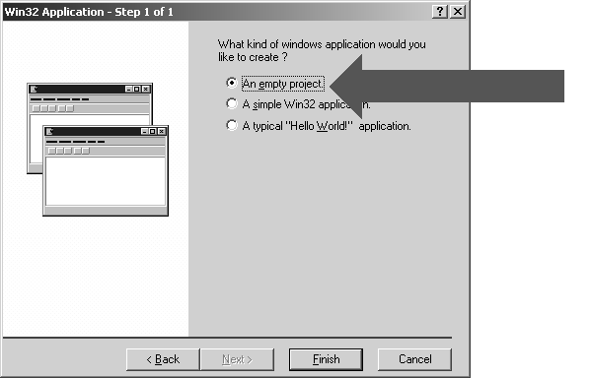.

5. Next, from the PROJECT menu, select ADD TO PROJECT, then FILES.... In the new window, find the subfolder that you created right at the beginning, select files of type “All Files”, then select BOTH of the files that you downloaded (click on one, then control-click on the other), then press “Open”.

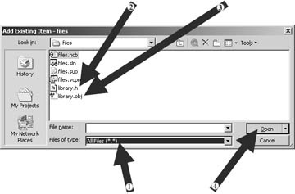

6. Then, from the PROJECT menu again, select ADD TO PROJECT, then NEW.... In the new window, select C++ SOURCE FILE, then decide on a name for your file and type it under FILE NAME. This is the name that your main program file will have, so call it something meaningful. If its for an assignment, the name should reflect which assignment it is; you will accumulate a lot of programs over the next 15 weeks, and should make it as easy as possible to work out which is which. Finally, press OK.

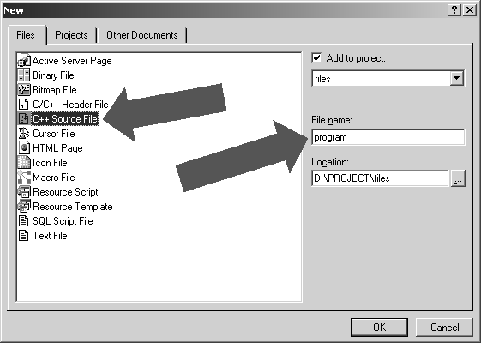
7. Select the FILE VIEW tab, so that you can make sure all three files appear correctly.

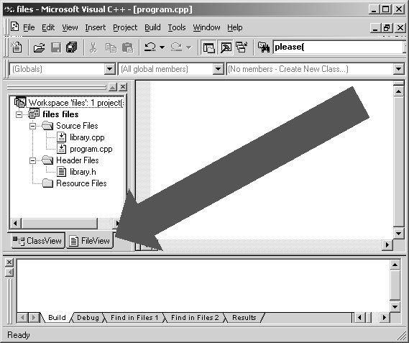

8. Type your program carefully in the big window to the right.

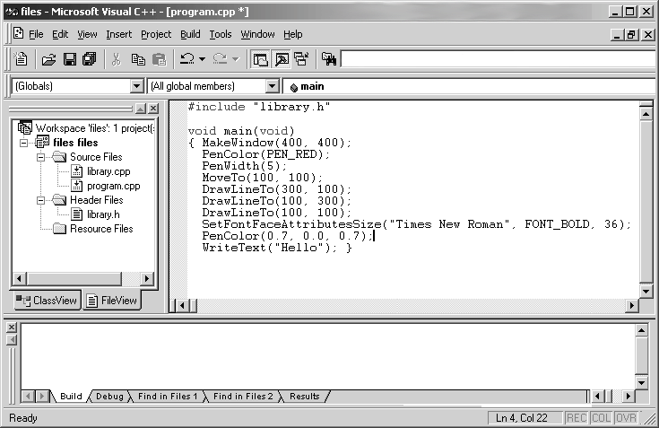
9. When you’ve finished typing the program, press the GO button in the tool bar. It is marked with a big footprint that I think is supposed to be an exclamation mark. Not that an exclamation mark would be any more logical than a footprint. Why couldn’t they just have a button that says “GO”?

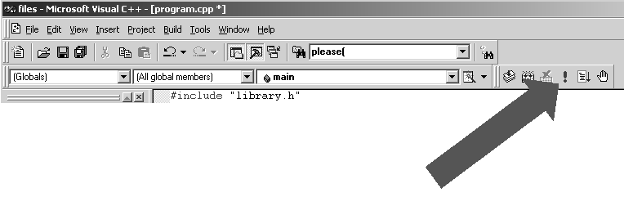

10. If you have made any mistakes, you will get an error message in the tiny, unreadably small window at the bottom. Use its vertical scroll bar to scroll back to the FIRST error message. Always try to fix the first error first, it may make the others just disappear. Double-click on the error message itself, and you’ll see a description of the error, plus a little mark beside your program at the approximate location of the error.

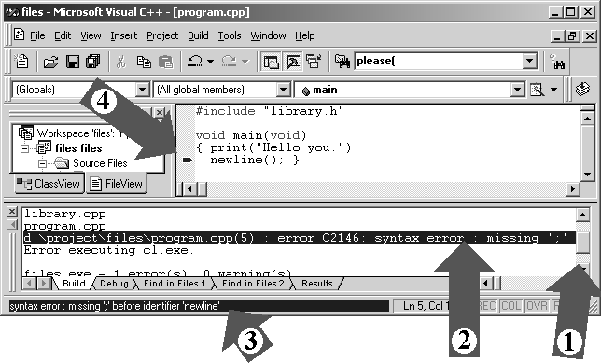
1 = Scroll bar used to make first error report visible
2 = Double click on the text of the error message itself
3 = See a readable version of the error description appear here.
It is surprisingly helpful sometimes. Here it correctly told me that I’d missed a semicolon.
4 = The program window automatically scrolls to the position of the error, and puts a mark near it.
11. Just correct the error (or try to), and press the GO button again. With large programs, it might take quite a few attempts before all the errors go away. You get used to it, and with practice it becomes much easier to see what the problem is right away. No matter how good you get at programming, you’ll still make mistakes.

12. Once you’ve got to the point where the compiler doesn’t give any error messages, pressing GO will actually make your program run. You see a new window appearing with the results of your program run in it.

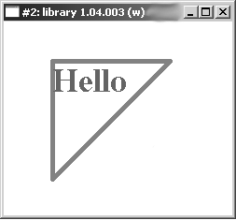

When you’ve finished admiring your work, just type control-C to make the window go away.

13. And there you have it.
If you look in the folders that you created at the beginning, you’ll see that a lot of new files have appeared. You can ignore most of them, but a few are useful.

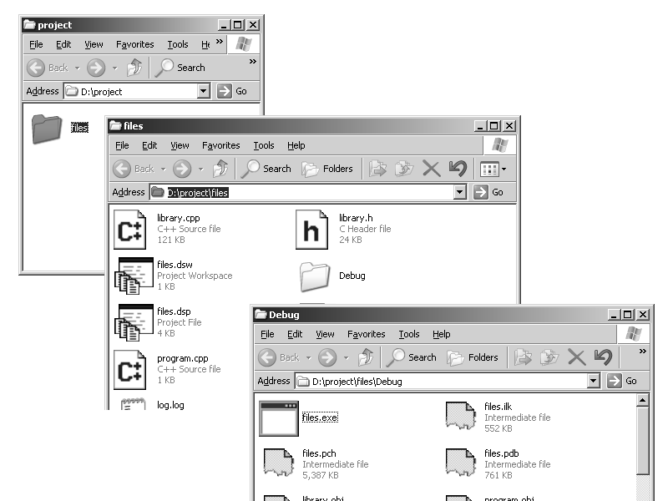

Notice that there is even a new folder, strangely called Debug. In it, you will see a file called something.exe (something is the name you gave to the project and original subfolder, “files” in this case). This is the executable version of your program. Using this file, you can re-run your program immediately at any time, without having to start the microsoft visual system again. Just double-click on your .exe file and it will run. You can put just that .exe file alone on a floppy and give it to someone else, and provided that they have a compatible computer, they’ll be able to run your program by double-clicking it themselves. It does not contain the human-readable version of the program that you typed. That is how companies can sell software without revealing their secret techniques.

In the original subfolder, you will of course still see the two files that you downloaded. You will also see another .cpp file (in this case program.cpp, program was the name we selected at step 6). This is the only part that you typed, so it is the only part you need to preserve if you want to keep your program safe. From this file you can quickly reconstruct everything else. It is also a very small file compared to the .exe, so you can afford to keep a lot of them.

If you want to move on to writing another program, you do not have to repeat all of these steps. All you have to do is make a copy of this .cpp file: Select the EDIT menu of the window that contains the file, and press COPY. Then select EDIT again and press PASTE. A copy of your file will appear. Rename it to something sensible (single-click the copy, then FILE then RENAME). Now you can go back to the microsoft compiler system and delete all the text of your program and type a new one in the same window.

Even if you exit from the microsoft system and turn your computer off, and come back to it a week later, you still don’t have to repeat the steps. Notice that the original subfolder (“files”) contains a file called files.dsw (if you chose a better name for your project, it will have that name instead, just look for a .dsw file, there should only be one). This is where a complete record of the state of your project is kept. All you ever have to do is double-click a DSW file, and the system will automatically restart, and re-open your project exactly as you left it.

Of course, if you’ve been working in the labs, you can’t rely on your files being left alone. That’s why FTP is so useful, Floppy discs help too, but ZIP discs are much better and much more reliable. Its probably worth the investment to get a couple then you’ll know you can carry all your work around with you without any risk of loss. Unless you like playing with big magnets.

