2005-02-01 Active Web Pages and CGI

[sratbag@rabbit] ~> ls
public_html

[sratbag@rabbit] ~> pico testone.html

<html>
<head>
<title>Test File One</title>
</head>
<body>
<h1>Test File One</h1>
The cat sat on the mat.<br>
One two three four five six seven.<br>
The time is now 7:07 pm, and it is Monday 31st January 2005.
<br><br><br>
</body>
</html>

[sratbag@rabbit] ~> cp testone.html public_html/
[sratbag@rabbit] ~> chmod 644 public_html/testone.html
[sratbag@rabbit] ~>

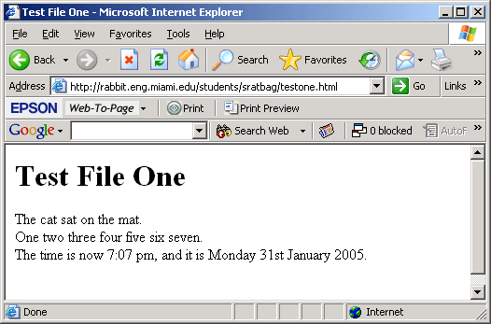

Now use our peculiar little program to turn this html file into a program...

[sratbag@rabbit] ~> cat testtwo.cpp

#include <iostream>

void main(void)
{ cout << "<html>\n";
cout << " <head>\n";
cout << " <title>Test File Two</title>\n";
cout << " </head>\n";
cout << " <body>\n";
cout << " <h1>Test File Two</h1>\n";
cout << " The cat sat on the mat.<br>\n";
cout << " One two three four five six seven.<br>\n";
cout << " The time is now 7:07 pm, and it is Monday 31st January 2005.<br>\n";
cout << " <br><br><br>\n";
cout << " </body>\n";
cout << "</html>\n"; }

[sratbag@rabbit] ~> CC testtwo.cpp -o testtwo
[sratbag@rabbit] ~> testtwo
<html>
<head>
<title>Test File Two</title>
</head>
<body>
<h1>Test File Two</h1>
The cat sat on the mat.<br>
One two three four five six seven.<br>
The time is now 7:07 pm, and it is Monday 31st January 2005.<br>
<br><br><br>
</body>
</html>

And also test another little feature...

[sratbag@rabbit] ~> cat testthree.cpp

#include <iostream>
#include <time.h>

void main(void)
{
time_t now=time(NULL);
cout << "The time is now " << ctime(&now);
}

[sratbag@rabbit] ~> CC testthree.cpp
[sratbag@rabbit] ~> a.out
The time is now Mon Jan 31 19:27:36 2005
[sratbag@rabbit] ~> a.out
The time is now Mon Jan 31 19:27:39 2005
[sratbag@rabbit] ~> a.out
The time is now Mon Jan 31 19:31:04 2005

Now we can combine these two ideas into one program...
[sratbag@rabbit] ~> cat testfour.cpp
#include <iostream>
#include <time.h>

void main(void)
{ cout << "Content-type: text/html\r\n\r\n";
cout << "<html>\n";
cout << " <head>\n";
cout << " <title>Test Program Four</title>\n";
cout << " </head>\n";
cout << " <body>\n";
cout << " <h1>Test Program Four</h1>\n";
cout << " The cat sat on the mat.<br>\n";
cout << " One two three four five six seven.<br>\n";
time_t now=time(NULL);
cout << " The time is now " << ctime(&now);
cout << " <br><br><br>\n";
cout << " </body>\n";
cout << "</html>\n"; }

[sratbag@rabbit] ~> CC testfour.cpp -o testfour.cgi
[sratbag@rabbit] ~> testfour.cgi
Content-type: text/html

<html>
<head>
<title>Test Program Four</title>
</head>
<body>
<h1>Test Program Four</h1>
The cat sat on the mat.<br>
One two three four five six seven.<br>
The time is now Mon Jan 31 19:30:07 2005
<br><br><br>
</body>
</html>

[sratbag@rabbit] ~> cp testfour.cgi public_html/
[sratbag@rabbit] ~> chmod 711 public_html/testfour.cgi

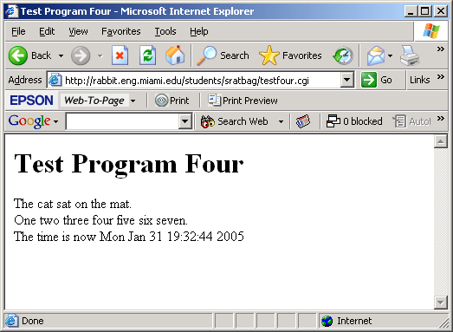

[sratbag@rabbit] ~> cat testfive.html

<html>
<head>
<title>Test File Five</title>
</head>
<body>
<h1>Test File Five</h1>
<form action=testsix.cgi method=get>
<table>
<tr>
<td> What is your Name?
<td> <input name="name" type=text>
<tr>
<td> Think of a number:
<td> <input name="number1" type=text>
<tr>
<td> And another number:
<td> <input name="number2" type=text>
<tr>
<td> Then click "submit"
<td> <input type=submit value="SUBMIT">
</table>
</form>
<br><br><br>
</body>
</html>

[sratbag@rabbit] ~> cp testfive.html public_html/
[sratbag@rabbit] ~> chmod 644 public_html/testfive.html

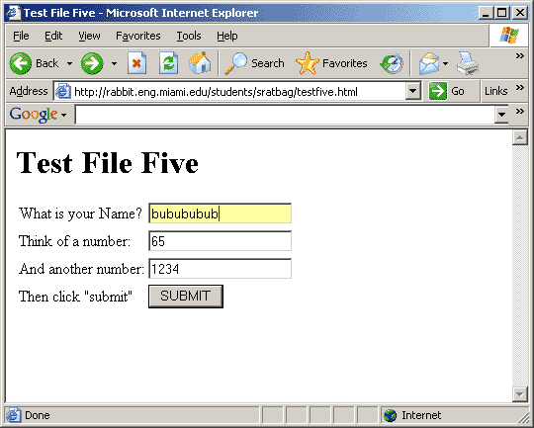

[sratbag@rabbit] ~> cat testsix.cpp

#include <iostream>
#include <stdlib.h>
#include <time.h>

void main(void)
{ cout << "Content-type: text/html\r\n\r\n";
cout << "<html>\n";
cout << " <head>\n";
cout << " <title>Test Program Six</title>\n";
cout << " </head>\n";
cout << " <body>\n";
cout << " <h1>Test Program Six</h1>\n";
cout << " your input was <tt>" << getenv("QUERY_STRING") << "</tt><br><br>\n";
time_t now=time(NULL);
cout << " The time is now " << ctime(&now);
cout << " <br><br><br>\n";
cout << " </body>\n";
cout << "</html>\n"; }

[sratbag@rabbit] ~> CC testsix.cpp -o testsix.cgi
[sratbag@rabbit] ~> cp testsix.cgi public_html/
[sratbag@rabbit] ~> chmod 711 public_html/testsix.cgi

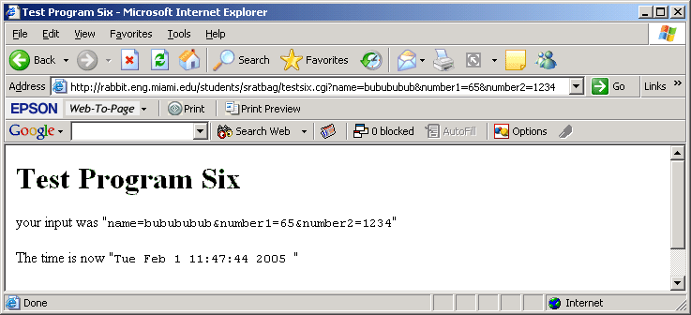

[sratbag@rabbit] ~> cat testseven.cpp

#include <iostream>
#include <stdlib.h>
#include <string>
#include <time.h>

string getinput(string inputs, string question)
{ string wanted = "&";
wanted = wanted + question;
wanted = wanted + "=";
int position = inputs.find(wanted, 0);
if (position<0)
return "";
position+=wanted.length();
int end = inputs.find("&", position+1);
return inputs.substr(position, end-position); }

void main(void)
{ cout << "Content-type: text/html\r\n\r\n";
cout << "<html>\n";
cout << " <head>\n";
cout << " <title>Test Program Seven</title>\n";
cout << " </head>\n";
cout << " <body>\n";
cout << " <h1>Test Program Seven</h1>\n";
string temp;
getline(cin, temp);
string inputs = "&";
inputs = inputs + temp;
inputs = inputs +"&";
cout << " your input was <tt>" << inputs << "</tt><br><br>\n";
cout << " your individual inputs were: <br>\n";
string name = getinput(inputs, "name");
string number1 = getinput(inputs, "number1");
string number2 = getinput(inputs, "number2");
cout << " name = '" << name << "'<br>\n";
cout << " number1 = '" << number1 << "'<br>\n";
cout << " number2 = '" << number2 << "'<br>\n";
time_t now=time(NULL);
cout << " The time is now " << ctime(&now) << "<br>\n";
cout << " and (number1+number2) is " << (number1+number2) << "<br>\n";
cout << " <br><br><br>\n";
cout << " </body>\n";
cout << "</html>\n"; }

[sratbag@rabbit] ~> CC testseven.cpp -o testseven.cgi
[sratbag@rabbit] ~> cp testseven.cgi public_html/testsevencgi
[sratbag@rabbit] ~> chmod 711 public_html/testseven.cgi
[sratbag@rabbit] ~> pico public_html/testfive.html

...
<form action=testsix.cgi method=get>
turned into
<form action=testseven.cgi method=post>
...

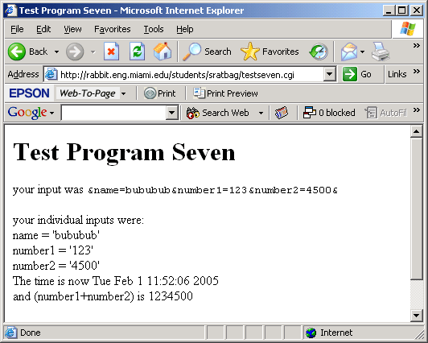

[sratbag@rabbit] ~> cat testeight.cpp
...
...
int stringtoint(string s)
{ int result=0, leng=s.length();
for (int i=0; i<leng; i+=1)
{ char c=s[i];
if (c<'0' || c>'9')
{ cout << "Error in input\n";
return -1; }
if (c=='0') result = result*10;
else if (c=='1') result = result*10 + 1;
else if (c=='2') result = result*10 + 2;
else if (c=='3') result = result*10 + 3;
else if (c=='4') result = result*10 + 4;
else if (c=='5') result = result*10 + 5;
else if (c=='6') result = result*10 + 6;
else if (c=='7') result = result*10 + 7;
else if (c=='8') result = result*10 + 8;
else if (c=='9') result = result*10 + 9; }
return result; }

void main(void)
{ ...
...
string number1 = getinput(inputs, "number1");
string number2 = getinput(inputs, "number2");
int value1 = stringtoint(number1);
int value2 = stringtoint(number2);
cout << " and (number1+number2) is " << (number1+number2) << "<br>\n";
cout << " and (value1+value2) is " << (value1+value2) << "<br>\n";
...
[sratbag@rabbit] ~> CC testeight.cpp -o testeight.cgi
[sratbag@rabbit] ~> cp testeight.cgi public_html/
[sratbag@rabbit] ~> chmod 711 public_html/testeight.cgi
[sratbag@rabbit] ~> pico public_html/testfive.html
...
<form action=testseven.cgi method=post>
turned into
<form action=testeight.cgi method=post>
...

