10/7 MICROSOFT-MIAMI ALUMNI PANEL

6:30pm-7:30pm in McArthur Engineering Building #202

**Come meet some great Software Engineer alums of Miami who are livin’ the dream here at Microsoft!**

10/8 CODING COMPETITION

6:30pm-8:30pm in McArthur Engineering Building #220

**Anyone who can code is welcome – any language, any skill level. Show us what you’ve got!**

CAMPUS INTERVIEWS

10/27-10/28. Apply online to be considered at www.microsoft.com/university

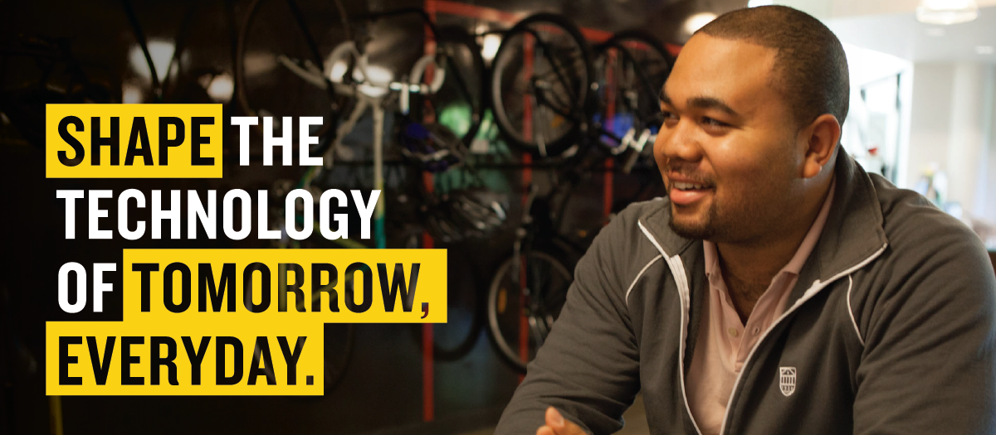

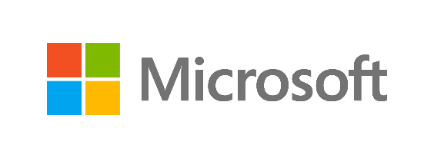

microsoft.com/university