Unix and Windows “compatibility”
Reading Directories
318 2006-10-26

#include <stdio.h>
#include <stdlib.h>
#include <string.h>
#include <fcntl.h>
#include <sys/stat.h>
#include <errno.h>
#include <time.h>

#ifdef unix

#include <pwd.h>
#include <unistd.h>
#include <sys/types.h>
#include <dirent.h>

#define _S_IWRITE 0644
#define xprintf printf

typedef unsigned int sizetype;

#endif

#ifdef _WIN32

#include "library.h" << --- Only needed for a graphics application

#include <windows.h>
#include <io.h>
#include <direct.h>
#include <conio.h>

#define O_RDONLY _O_RDONLY
#define O_WRONLY _O_WRONLY
#define O_BINARY _O_BINARY
#define O_CREAT _O_CREAT
#define S_ISUID 0
#define S_IFLNK 998877
#define strcasecmp _stricmp
#define usleep(n) Sleep((n)/1000)
#define getcwd _getcwd

typedef int sizetype;

struct DIR
{ HANDLE hand;
WIN32_FIND_DATA fd;
int ok;
char *name; };

struct dirent
{ char d_name[520]; };

DIR * opendir(char * dirnm)
{ size_t len=strlen(dirnm);
char * dirname=new char[len+4];
strcpy(dirname, dirnm);
strcpy(dirname+len, "\\*");
DIR * dir = new DIR;
dir->name=dirname;
dir->ok=1;
dir->hand=FindFirstFile(dirname, &dir->fd);
dirname[len]=0;
if (dir->hand==INVALID_HANDLE_VALUE)
{ dir->ok=0;
return dir; }
if (dir->hand==NULL)
{ dir->ok=0;
return dir; }
return dir; }

dirent * readdir(DIR * dir)
{ static dirent de;
if (!dir->ok)
return NULL;
strncpy(de.d_name, dir->fd.cFileName, 515);
dir->ok=FindNextFile(dir->hand, &dir->fd);
return &de; }

void closedir(DIR * dir)
{ FindClose(dir->hand);
delete[] dir->name;
delete dir;
printf("End of test\n\n"); }

char *getpass(const char * prompt)
{ static char r[100];
int len=0;
printf("%s", prompt);
fflush(stdout);
while (1)
{ int c=_getch();
if (c=='\r' || c=='\n') break;
putchar('*');
fflush(stdout);
if (len<98)
{ r[len]=c;
len+=1; } }
r[len]=0;
return r; }

#endif

void main(void)
{ DIR * d = opendir(".");
if (d==NULL)
{ xprintf("Can't read directory \".\"\n");
exit(1); }
for (int i=1; 1; i+=1)
{ dirent * entry = readdir(d);
if (entry==NULL) break;
xprintf("%3d: %s\n", i, entry->d_name); }
xprintf("All done.\n"); }
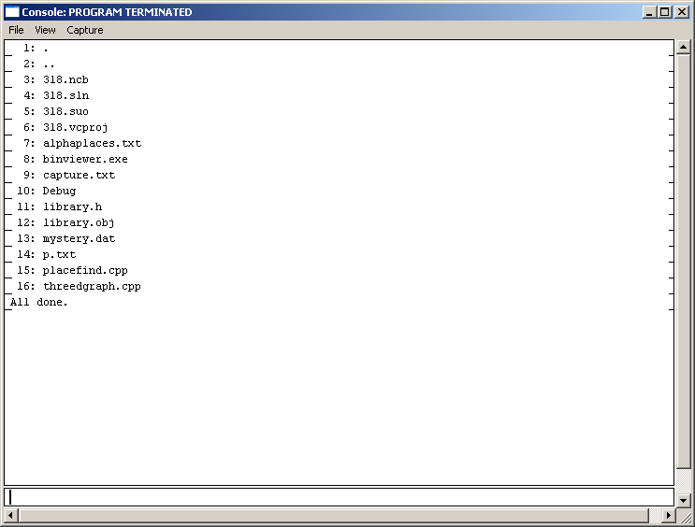

$ CC dirtest.cpp
$ a.out
1: .
2: ..
3: contest
4: department
5: class
6: lisp0297
7: javaudp
8: frac
...
...
...
462: interface2.cpp
463: words.cpp
464: words2.cpp
All done.
$

