218 2005-02-01 Active Web Pages and CGI

[sratbag@rabbit] ~> ls
public_html

[sratbag@rabbit] ~> pico testone.html

<html>
<head>
<title>Test File One</title>
</head>
<body>
<h1>Test File One</h1>
The cat sat on the mat.<br>
One two three four five six seven.<br>
The time is now 7:07 pm, and it is Monday 31st January 2005.
<br><br><br>
</body>
</html>

[sratbag@rabbit] ~> cp testone.html public_html/
[sratbag@rabbit] ~> chmod 644 public_html/testone.html
[sratbag@rabbit] ~>

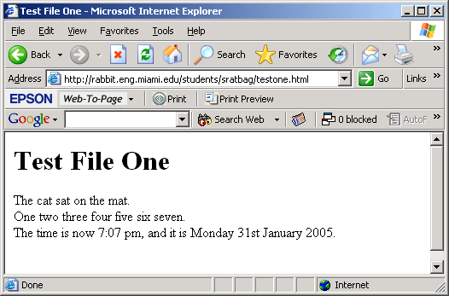

Now use our peculiar little program to turn this html file into a program...

[sratbag@rabbit] ~> cat testtwo.cpp

#include <iostream>

void main(void)
{ cout << "<html>\n";
cout << " <head>\n";
cout << " <title>Test File Two</title>\n";
cout << " </head>\n";
cout << " <body>\n";
cout << " <h1>Test File Two</h1>\n";
cout << " The cat sat on the mat.<br>\n";
cout << " One two three four five six seven.<br>\n";
cout << " The time is now 7:07 pm, and it is Monday 31st January 2005.<br>\n";
cout << " <br><br><br>\n";
cout << " </body>\n";
cout << "</html>\n"; }

[sratbag@rabbit] ~> CC testtwo.cpp -o testtwo
[sratbag@rabbit] ~> testtwo
<html>
<head>
<title>Test File Two</title>
</head>
<body>
<h1>Test File Two</h1>
The cat sat on the mat.<br>
One two three four five six seven.<br>
The time is now 7:07 pm, and it is Monday 31st January 2005.<br>
<br><br><br>
</body>
</html>

And also test another little feature...

[sratbag@rabbit] ~> cat testthree.cpp

#include <iostream>
#include <time.h>

void main(void)
{
time_t now=time(NULL);
cout << "The time is now " << ctime(&now);
}

[sratbag@rabbit] ~> CC testthree.cpp
[sratbag@rabbit] ~> a.out
The time is now Mon Jan 31 19:27:36 2005
[sratbag@rabbit] ~> a.out
The time is now Mon Jan 31 19:27:39 2005
[sratbag@rabbit] ~> a.out
The time is now Mon Jan 31 19:31:04 2005

Now we can combine these two ideas into one program...
[sratbag@rabbit] ~> cat testfour.cpp
#include <iostream>
#include <time.h>

void main(void)
{ cout << "Content-type: text/html\r\n\r\n";
cout << "<html>\n";
cout << " <head>\n";
cout << " <title>Test Program Four</title>\n";
cout << " </head>\n";
cout << " <body>\n";
cout << " <h1>Test Program Four</h1>\n";
cout << " The cat sat on the mat.<br>\n";
cout << " One two three four five six seven.<br>\n";
time_t now=time(NULL);
cout << " The time is now " << ctime(&now);
cout << " <br><br><br>\n";
cout << " </body>\n";
cout << "</html>\n"; }

[sratbag@rabbit] ~> CC testfour.cpp -o testfour.cgi
[sratbag@rabbit] ~> testfour.cgi
Content-type: text/html

<html>
<head>
<title>Test Program Four</title>
</head>
<body>
<h1>Test Program Four</h1>
The cat sat on the mat.<br>
One two three four five six seven.<br>
The time is now Mon Jan 31 19:30:07 2005
<br><br><br>
</body>
</html>

[sratbag@rabbit] ~> cp testfour.cgi public_html/
[sratbag@rabbit] ~> chmod 711 public_html/testfour.cgi

